Client: Deltares
RTO overtopping module
Test plan
CONCEPT

Authors: B. Kuijper
M.T. Duits
R.G. Kamp

Contents
1 Introduction 1
2 Basic tests and output 3
2.1 Basic tests 3
2.2 Output 4
3 Expected results 5
4 Tests for cross sections with only one segment 7
5 Tests for cross sections with two segments 9
6 Tests for cross sections with three segments (one berm) 13
7 Tests for cross sections with four segments 15
8 Tests for cross sections with five segments (two berms) 19
9 Overview test series 21

List of figures
Figure 2-1: Example for the output of the test series 4
Figure 4-1: Geometry for cross section nr. 1 7
Figure 5-1: Geometry for cross section nr. 2 10
Figure 5-2: Geometry for cross section nr. 3 11
Figure 6-1: Geometry for cross section nr. 4 13
Figure 7-1: Geometry for cross section nr. 5 15
Figure 7-2: Geometry for cross section nr. 6 16
Figure 8-1: Geometry for cross section nr. 7 19
Figure 8-2: Geometry for cross section nr. 8 20

Introduction
This document is the test plan of the RTO overtopping module. It presents only tests in the form of test series. Therefore both the test series and cross sections are proposed for the tests. The test series are divided in two parts: basic test series and cross section specific test series. The basic tests are described in chapter 2, the cross section specific test series are presented in the chapters 4 to 8. In chapter 3 the expected results are given in general terms.

This test plan presents test series for cross sections with one, two, three, four and five segments. In five chapters, 4 to 8, the test series are proposed. Each chapter handles a specific number of segments. An overview of the proposed number of test series is given in chapter 9.

The output of the RTO overtopping module is the 2% wave run-up and the overtopping discharge. Correctness of the computation results will be determined by visual inspection. A test will fail as the results didn't fit the expected behaviour.

Basic tests and output

Basic tests
The overtopping module has 4 input parameters: water level, wave height, wave period (spectral wave period) and the wave direction. In practice the wave height and the wave period are correlated. For instance: a large wave height in combination with a short wave period isn't very likely. This combination gives steep waves. The steepness of a wave can be computed by
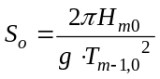,
with
S_{o} the wave steepness [-]
H_{m0} the wave height [m]
T_{m-1,0} the spectral wave period [s]
g the gravity constant [m/s²].

The value of the wave steepness will vary in practice just limited. To prevent computations with non-necessary combinations of wave heights and wave periods test series will have input that consists of water levels, wave heights, wave steepness and wave directions. The basic values are presented in Table 2-1. For the wave direction two values are chosen. One value isn't enough because for wave directions larger than 80 degrees some additional reductions are made. These also have to be tested.

Input value | Basic value
Water level [m+NAP] | 3.0
Wave height [m] | 2.0
Wave steepness [-] | 0.04
Wave direction  [degrees wrt dike normal] | 0.0  85.0
Table 2-1 Overview basic values for test series

The basic values as presented in Table 2-1 are related to the chosen cross sections in the chapters 4 to 8 in order to compute overtopping discharges that on the boundary of failing non-failing (1 – 100 l/s/m).

Using the basic values from Table 2-1 the spectral wave period is in the basic situation – with use of formula – equal to 5.66 sec. Rewriting formula can help to compute the spectral wave period from the wave height and the wave steepness:
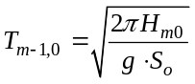.
Starting with the basic values from Table 2-1 seven test series are composed in which each time only one values is varied. The seven test series are presented in Table 2-2 and the are the basic test series. Per cross section some cross section specific test series are presented in which the cross section itself is varied and the roughness.

 | Water level [m+NAP] | Wave height  [m] | Wave steepness [-] | Wave direction  [° wrt dike normal]
Test series 1 | -2 to 6 step 0.01 | 2.0 | 0.04 | 0.0
Test series 2 | -2 to 6 step 0.01 | 2.0 | 0.04 | 85.0
Test series 3 | 3.0 | 0 to 5 step 0.01 | 0.04 | 0.0
Test series 4 | 3.0 | 0 to 5 step 0.01 | 0.04 | 85.0
Test series 5 | 3.0 | 2.0 | 0.001 to 0.07 step: 0.001 | 0.0
Test series 6 | 3.0 | 2.0 | 0.001 to 0.07 step: 0.001 | 85.0
Test series 7 | 3.0 | 2.0 | 0.04 | 0 to 180 step 1
Table 2-2 Overview basic test series

All examined cross sections will have a toe on -2 m+NAP and a crest on 6 m+NAP. That's why the test series for the water level in Table 2-2 (test series 1 and 2) starts with a water level equal to -2 m+NAP and ends with a water level equal to 6 m+NAP. There will be no tests for water levels above the crest of a cross section and no tests for water levels below the toe of a cross section. The background is that the RTO overtopping module is not applicable for these two situations.

Output
Two output parameters will be examined: wave run-up (z_{2%}) and the overtopping discharge. The output will presented by figures with the varied parameter on the x-axis. An example is presented below for the slope of the cross section. Correctness of the computation results will be determined by visual inspection. Expected behaviour is described in the next chapter.

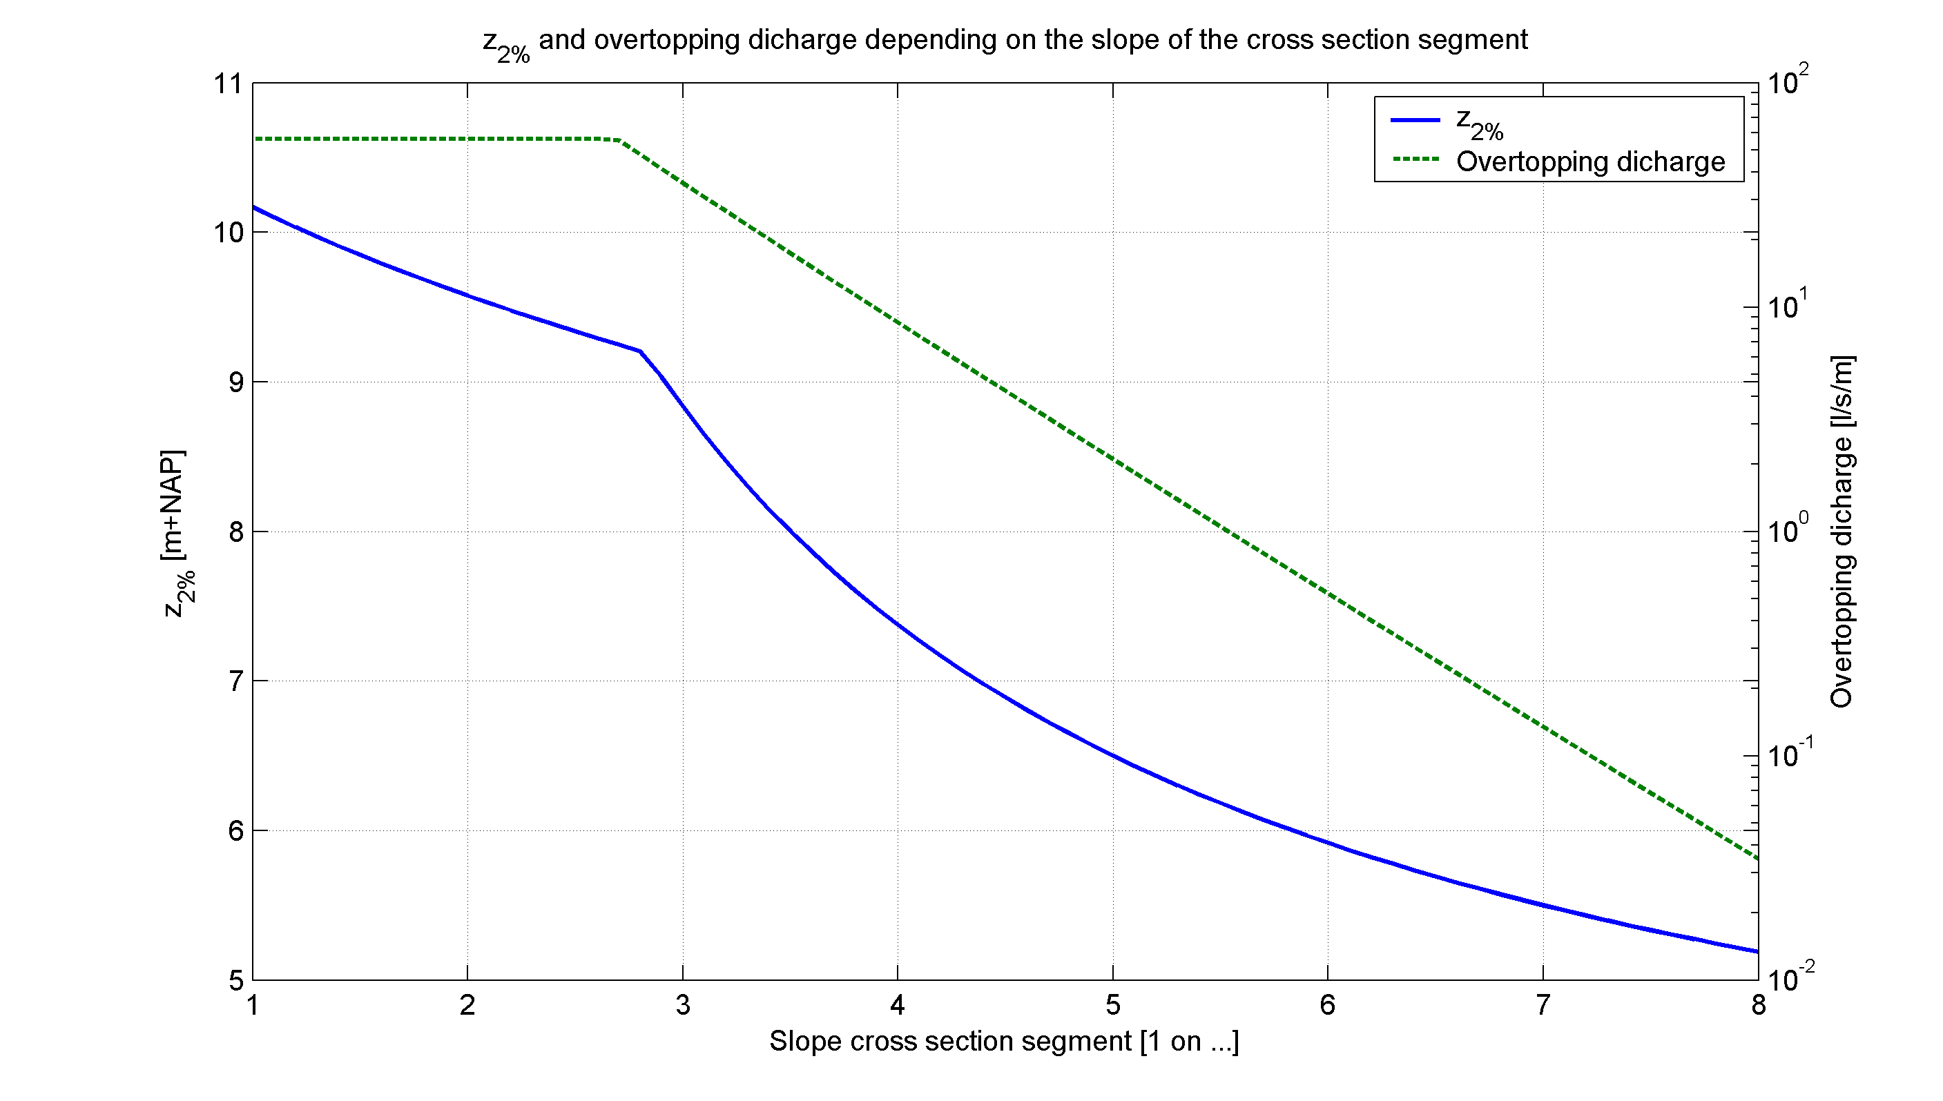
Figure 2-1: Example for the output of the test series

Expected results
The expected results for the test series are as follows:
- If the water level increases the z_{2%} and the overtopping discharge increases.
- If the wave height increases the z_{2%} and the overtopping discharge increases.
- If the wave steepness increases the z_{2%} and the overtopping discharge decreases.
- If the wave direction increases the z_{2%} and the overtopping discharge decreases.
- If the slope decreases the z_{2%} and the overtopping discharge decreases.
- If the roughness coefficient decreases the z_{2%} and the overtopping discharge decreases.
- If the length of a berm increases the z_{2%} and the overtopping discharge decreases.
- If the level of a berm increases the z_{2%} and the overtopping discharge decreases.

There will be test series who conflict for a part of the test series with the above rules. Expected situations are the cross sections with three or more segments in combination with different roughness coefficients on the segments (chapters 6, 7 and 8). The inconsistencies are a consequence of the derived mathematical model for wave overtopping [TAW, 2002]. The transition of non-breaking waves to breaking waves is infamous on this point. Also the elision of reduction factors made inconsistencies possible.

If inconsistencies appear in test series with simple cross sections (chapters 4 and 5) there must be an error in the code of the overtopping module.

Tests for cross sections with only one segment
This chapter describes the tests for cross sections with only one segment. In Figure 4-2 a cross section with one segment is presented. This cross section has the steepest slope possible. The idea to choose for this cross section lies in fact that possible inconsistencies for sure appear for cross sections that are just allowed. The cross section in Figure 4-2 is tested with the basic test series as described in paragraph 2.1 and the extra additional tests as presented in Table 4-3. The test series in Table 4-3 are combined with the water level, wave height and wave steepness from Table 2-1.

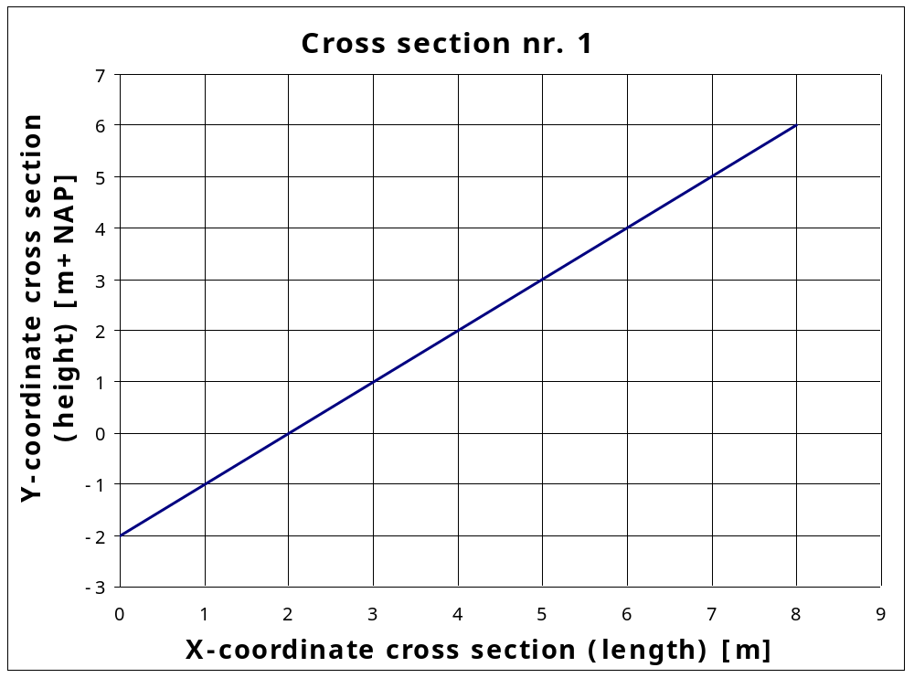
x-coordinates | 0 | 8
y-coordinates | -2 | 6
slope | 1:1
Roughness coefficient [-] | 1.0
Figure 4-2: Geometry for cross section nr. 1

 | Parameter to vary in the test series | Variation range | Wave direction  [° wrt dike normal]
Test series 8 | Slope [-] | 1:1, 1:1.1, 1:1.2, .... 1:7.9, 1:8⁽⁾ | 0.0
Test series 9 | Slope [-] | 1:1, 1:1.1, 1:1.2, .... 1:7.9, 1:8(Error: Reference source not found) | 85.0
Test series 10 | Roughness coefficient [-] | 0.5 to 1.0 step 0.01 | 0.0
Test series 11 | Roughness coefficient [-] | 0.5 to 1.0 step 0.01 | 85.0
Table 4-3 Additional test series cross section nr. 1

Tests for cross sections with two segments
This chapter describes the test series for cross sections with two segments (i.e. cross sections with a buckling point). Two basic cross sections with a buckling point are chosen to test the overtopping module. These two cross sections are presented in Figure 5-3 and Figure 5-4. The first cross sections has a flat first segment and a steep second segment (Figure 5-3). The second cross sections has a steep first segment and a flat second segment (Figure 5-4). These two cross sections are tested with the basic test series as described in paragraph 2.1 and additional test series in this chapter. Table 5-4 describes the additional test series for the first cross section (Figure 5-3) and Table 5-5 describes the additional test series for the second cross section (Figure 5-4). In these tests the slope of the two segments are varied and the position of the buckling point. Table 5-6 describes additional test series for both cross sections and handle the roughness coefficients. All test series in Table 5-4, Table 5-5 and Table 5-6 are combined with the water level, wave height and wave steepness from Table 2-1.

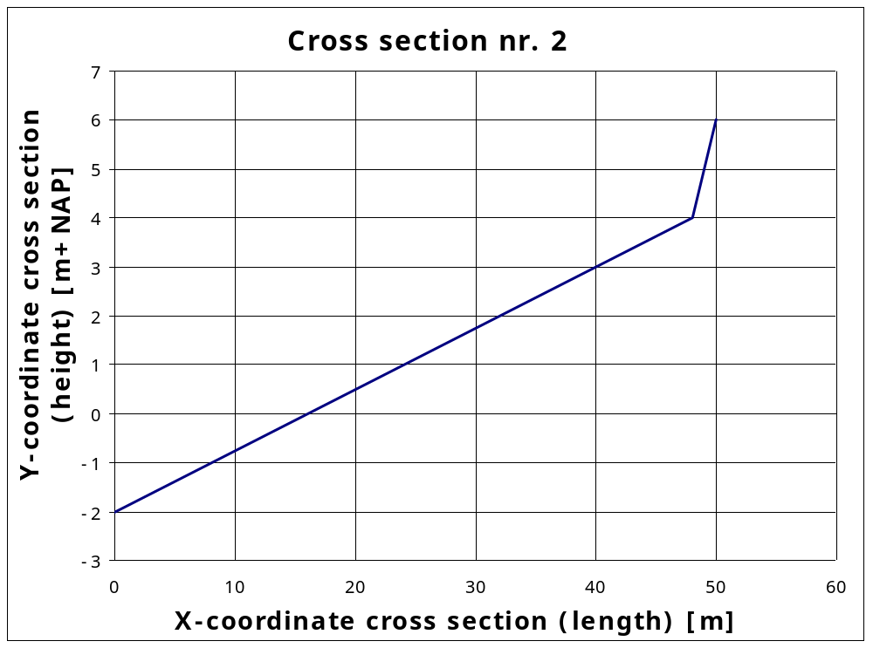
x-coordinates | 0 | 48 | 50
y-coordinates | -2 | 4 | 6
slope | 1:8 | 1:1
Roughness coefficient [-] | 1.0 | 1.0
Figure 5-3: Geometry for cross section nr. 2

 | Parameter to vary in the test series | Variation range | Wave direction  [° wrt dike normal]
Test series 8 | Slope lower segment [-] | 1:1, 1:1.1, 1:1.2, .... 1:7.9, 1:8⁽⁾ | 0.0
Test series 9 | Slope lower segment [-] | 1:1, 1:1.1, 1:1.2, .... 1:7.9, 1:8(Error: Reference source not found) | 85.0
Test series 10 | Slope upper segment [-] | 1:1, 1:1.1, 1:1.2, .... 1:7.9, 1:8⁽⁾ | 0.0
Test series 11 | Slope upper segment [-] | 1:1, 1:1.1, 1:1.2, .... 1:7.9, 1:8(Error: Reference source not found) | 85.0
Test series 12 | Position of buckling point [m+NAP] | 2 to 48 step 1⁽⁾ | 0.0
Test series 13 | Position of buckling point [m+NAP] | 2 to 48 step 1(Error: Reference source not found) | 85.0
Table 5-4 Additional test series cross section nr. 2

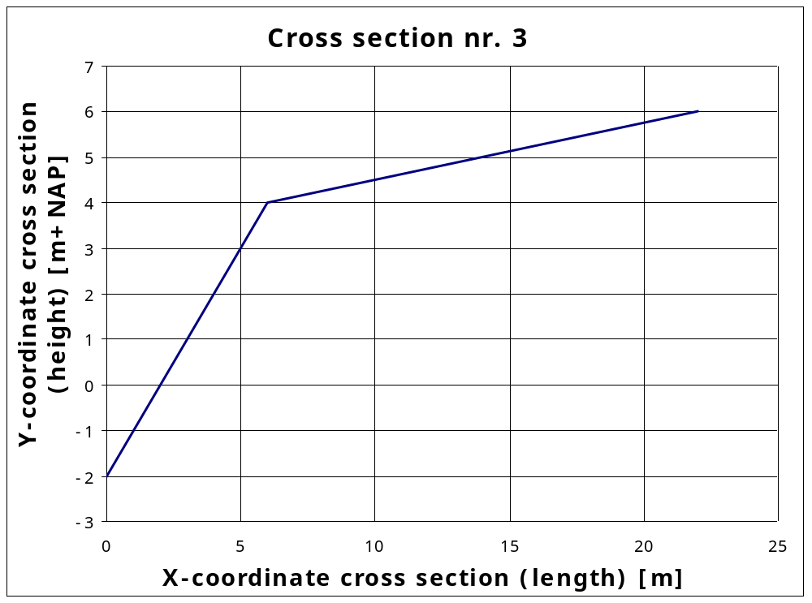
x-coordinates | 0 | 6 | 22
y-coordinates | -2 | 4 | 6
slope | 1:1 | 1:8
Roughness coefficient [-] | 1.0 | 1.0
Figure 5-4: Geometry for cross section nr. 3

 | Parameter to vary in the test series | Variation range | Wave direction  [° wrt dike normal]
Test series 8 | Slope lower segment [-] | 1:1, 1:1.1, 1:1.2, .... 1:7.9, 1:8⁽⁾ | 0.0
Test series 9 | Slope lower segment [-] | 1:1, 1:1.1, 1:1.2, .... 1:7.9, 1:8(Error: Reference source not found) | 85.0
Test series 10 | Slope upper segment [-] | 1:1, 1:1.1, 1:1.2, .... 1:7.9, 1:8⁽⁾ | 0.0
Test series 11 | Slope upper segment [-] | 1:1, 1:1.1, 1:1.2, .... 1:7.9, 1:8(Error: Reference source not found) | 85.0
Test series 12 | Position of buckling point [m+NAP] | 2 to 6 step 0.1⁽⁾ | 0.0
Test series 13 | Position of buckling point [m+NAP] | 2 to 6 step 0.1(Error: Reference source not found) | 85.0
Table 5-5 Additional test series cross section nr. 3

 | Parameter to vary in the test series | Variation range | Wave direction  [° wrt dike normal]
Test series 14 | Roughness coefficient both segment [-] | 0.5 to 1.0 step 0.01 | 0.0
Test series 15 | Roughness coefficient both segment [-] | 0.5 to 1.0 step 0.01 | 85.0
Test series 16 | Roughness coefficient lower segment [-] | 0.5 to 1.0 step 0.01 | 0.0
Test series 17 | Roughness coefficient lower segment [-] | 0.5 to 1.0 step 0.01 | 85.0
Test series 18 | Roughness coefficient upper segment [-] | 0.5 to 1.0 step 0.01 | 0.0
Test series 19 | Roughness coefficient upper segment [-] | 0.5 to 1.0 step 0.01 | 85.0
Table 5-6 Additional test series for both cross sections nr. 2 and nr. 3

Tests for cross sections with three segments (one berm)
This chapter describes the test series for cross sections with three segments. All tests are executed with one basic cross section, which is presented in Figure 6-5. The cross section in this figure has a lower and upper segment and a berm. In two test series the slope of the berm segment is varied from berm to non-berm (series 8 and 9 in Table 6-7). So tests with three sequential non-berm segments are included. The cross section in this chapter is tested with the basic test series as described in paragraph 2.1 and the extra additional tests as presented in Table 6-7. The test series in Table 6-7 are combined with the water level, wave height and wave steepness from Table 2-1. In Table 6-7 the slope of the segments is varied, the length of the berm is varied and the roughness coefficients are varied. The height of the berm is on purpose not varied. A test series in which the berm is varied is comparable with the test series in which the water level is varied. In the previous chapter – with cross sections with only two segments – the height of the buckling point is already examined.

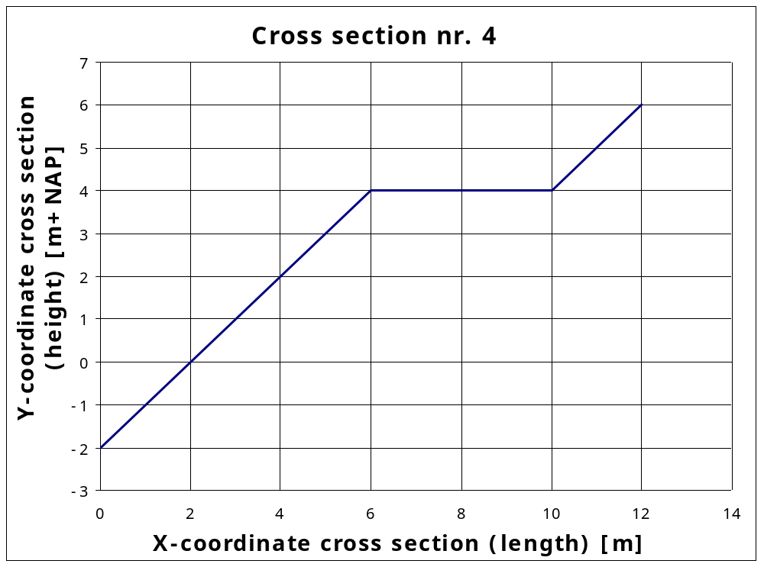
x-coordinates | 0 | 6 | 10 | 12
y-coordinates | -2 | 4 | 4 | 6
slope | 1:1 | 0 | 1:1
Roughness coefficient [-] | 1.0 | 1.0 | 1.0
Figure 6-5: Geometry for cross section nr. 4

 | Parameter to vary in the test series | Variation range | Wave direction  [° wrt dike normal]
Test series 8 | Slope berm segment [-] | 1:1 to 1:8 and 1:15 to 1:400⁽⁾ | 0.0
Test series 9 | Slope berm segment [-] | 1:1 to 1:8 and 1:15 to 1:400(Error: Reference source not found) | 85.0
Test series 10 | Slope lower and upper segment [-] | 1:1, 1:1.1, 1:1.2, .... 1:7.9, 1:8⁽⁾ | 0.0
Test series 11 | Slope lower and upper segment [-] | 1:1, 1:1.1, 1:1.2, .... 1:7.9, 1:8(Error: Reference source not found) | 85.0
Test series 12 | Length berm segment [m] | 0 to 20 step 1 | 0.0
Test series 13 | Length berm segment [m] | 0 to 20 step 1 | 85.0
Test series 14 | Roughness coefficient berm segment [-] | 0.5 to 1.0 step 0.01 | 0.0
Test series 15 | Roughness coefficient berm segment [-] | 0.5 to 1.0 step 0.01 | 85.0
Test series 16 | Roughness coefficient [-] lower and upper segment | 0.5 to 1.0 step 0.01 | 0.0
Test series 17 | Roughness coefficient [-] lower and upper segment | 0.5 to 1.0 step 0.01 | 85.0
Table 6-7 Additional test series cross section nr. 4

Tests for cross sections with four segments
This chapter describes the test series for cross sections with four segments. For these tests two basic cross sections are chosen. These are presented in Figure 7-6 and Figure 7-7. They have both two sequential berms with the first berm almost as steep as possible and the second berm is horizontal. They only differ in the height of the berms: in the first cross section the horizontal berm has a height of 4.0 m+NAP (Figure 7-6); in the second cross section this height is 2 m+NAP (Figure 7-7). In the first cross section the steepness of the first berm can be varied from berm to non-berm (Table 7-8); in the second cross section the steepness of the second berm can be varied from berm to non-berm (Table 7-9). The two cross sections are tested by the basic test series as described in paragraph 2.1 and the extra additional tests as presented in Table 7-10. In Table 7-10 the slope of the non-berm-segments is varied and the roughness coefficients. The test series in Table 7-8, Table 7-9 and Table 7-10 are combined with the water level, wave height and wave steepness from Table 2-1.

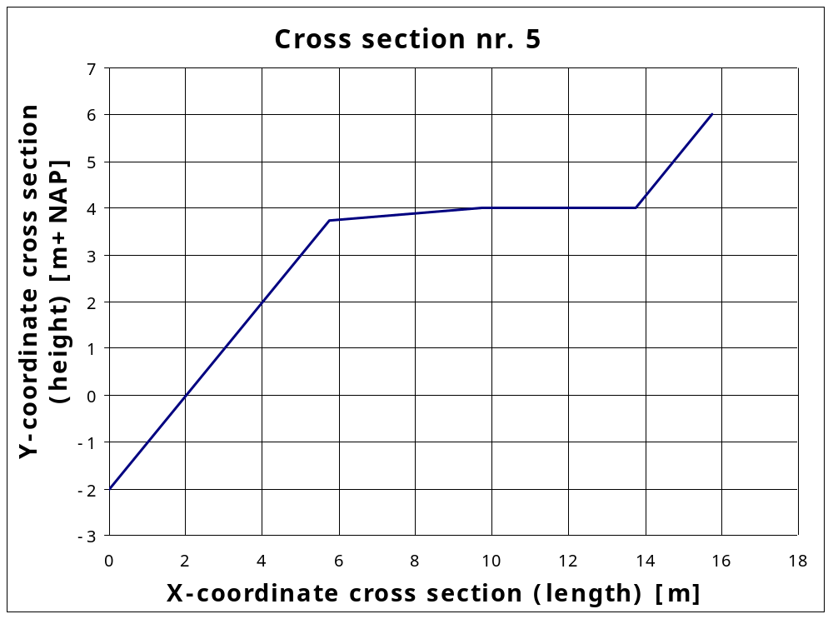
x-coordinates | 0 | 5.75 | 9.75 | 13.75 | 15.75
y-coordinates | -2 | 3.75 | 4 | 4 | 6
slope | 1:1 | 1:16 | 0 | 1:1
Roughness coefficient [-] | 1.0 | 1.0 | 1.0 | 1.0
Figure 7-6: Geometry for cross section nr. 5

 | Parameter to vary in the test series | Variation range | Wave direction  [° wrt dike normal]
Test series 8 | Slope first berm segment [-] | 1:1 to 1:8, 1:16 to 1:400 and horizontal | 0.0
Test series 9 | Slope first berm segment [-] | 1:1 to 1:8, 1:16 to 1:400 and horizontal | 85.0
Table 7-8 Additional test series cross section nr. 5

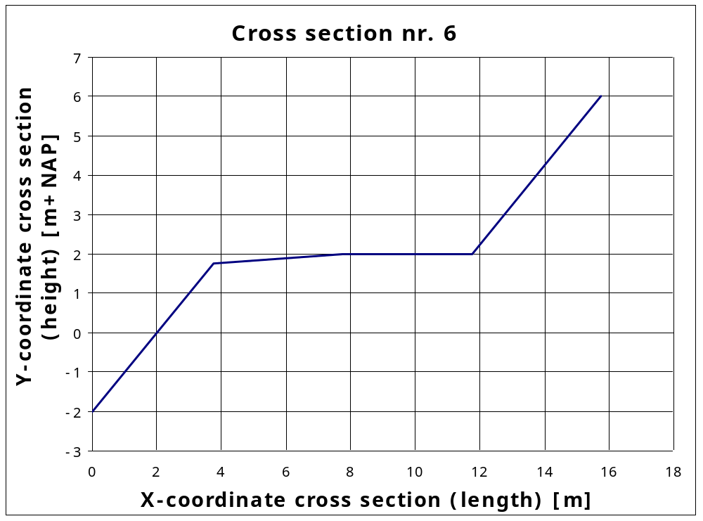
x-coordinates | 0 | 3.75 | 5.75 | 11.75 | 15.75
y-coordinates | -2 | 1.75 | 2 | 2 | 6
slope | 1:1 | 1:16 | 0 | 1:1
Roughness coefficient [-] | 1.0 | 1.0 | 1.0 | 1.0
Figure 7-7: Geometry for cross section nr. 6

 | Parameter to vary in the test series | Variation range | Wave direction  [° wrt dike normal]
Test series 8 | Slope second berm segment [-] | 1:1 to 1:8, 1:16 to 1:400 and horizontal | 0.0
Test series 9 | Slope second berm segment [-] | 1:1 to 1:8, 1:16 to 1:400 and horizontal | 85.0
Table 7-9 Additional test series cross section nr. 6

 | Parameter to vary in the test series | Variation range | Wave direction  [° wrt dike normal]
Test series 10 | Slope lower and upper segment [-] | 1:1, 1:1.1, 1:1.2, .... 1:7.9, 1:8 | 0.0
Test series 11 | Slope lower and upper segment [-] | 1:1, 1:1.1, 1:1.2, .... 1:7.9, 1:8 | 85.0
Test series 12 | Roughness coefficient first berm segment [-] | 0.5 to 1.0 step 0.01 | 0.0
Test series 13 | Roughness coefficient first berm segment [-] | 0.5 to 1.0 step 0.01 | 85.0
Test series 14 | Roughness coefficient second berm segment [-] | 0.5 to 1.0 step 0.01 | 0.0
Test series 15 | Roughness coefficient second berm segment [-] | 0.5 to 1.0 step 0.01 | 85.0
Test series 16 | Roughness coefficient lower segment and second berm segment [-] | 0.5 to 1.0 step 0.01 | 0.0
Test series 17 | Roughness coefficient lower segment and second berm segment [-] | 0.5 to 1.0 step 0.01 | 85.0
Test series 18 | Roughness coefficient first berm segment and upper segment [-] | 0.5 to 1.0 step 0.01 | 0.0
Test series 19 | Roughness coefficient first berm segment and upper segment [-] | 0.5 to 1.0 step 0.01 | 85.0
Table 7-10 Additional test series cross section nr. 5 and nr. 6

Tests for cross sections with five segments (two berms)
This chapter describes the test series for cross sections with five segments. From all possible cross sections with five segments only two cross sections with two berms are chosen to test the overtopping module. These two cross sections are presented in Figure 8-8 and Figure 8-9. These two cross sections only differ in the slope of the two berms: in Figure 8-8 the berms are horizontal and in Figure 8-8 the berms are almost as steep as possible. These two cross sections are tested by the basic test series as described in paragraph 2.1 and the additional tests as presented in Table 8-11. The test series in Table 8-11 are combined with the water level, wave height and wave steepness from Table 2-1. In Table 8-11 the slope of the non-berm-segments is varied and the roughness coefficients.

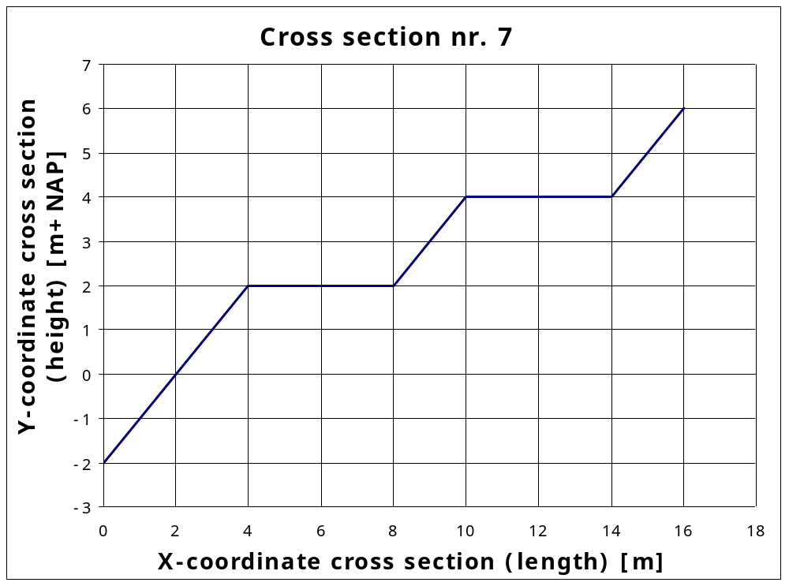
x-coordinates | 0 | 4 | 8 | 10 | 14 | 16
y-coordinates | -2 | 2 | 2 | 4 | 4 | 6
slope | 1:1 | 0 | 1:1 | 0 | 1:1
Roughness coefficient [-] | 1.0 | 1.0 | 1.0 | 1.0 | 1.0
Figure 8-8: Geometry for cross section nr. 7

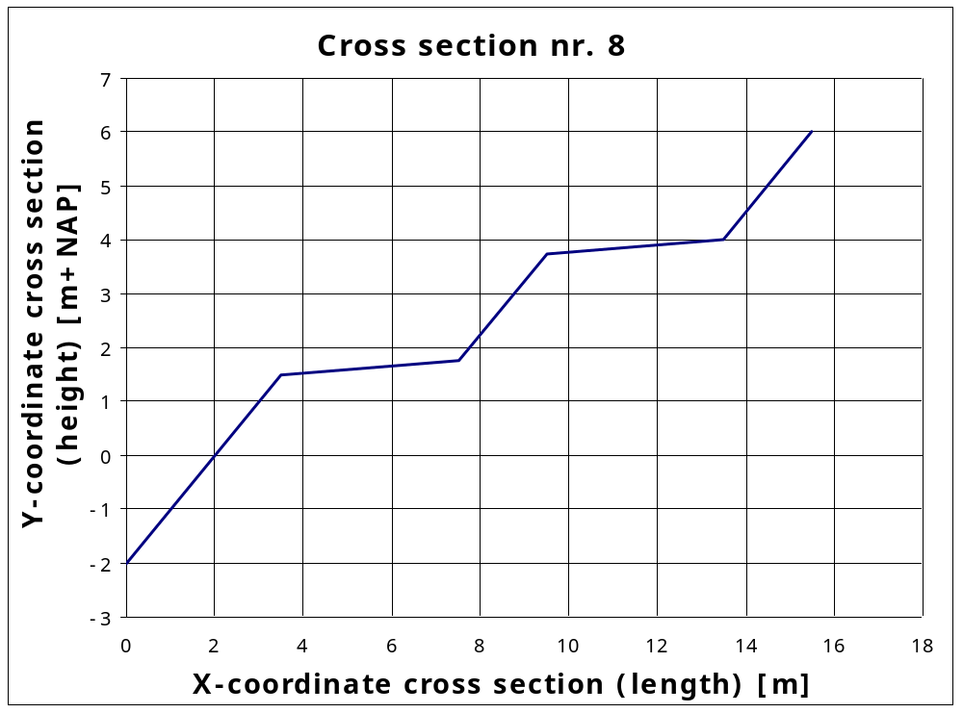
x-coordinates | 0 | 3.5 | 7.5 | 9.5 | 13.5 | 15.5
y-coordinates | -2 | 1.5 | 1.75 | 3.75 | 4 | 6
slope | 1:1 | 1:16 | 1:1 | 1:16 | 1:1
Roughness coefficient [-] | 1.0 | 1.0 | 1.0 | 1.0 | 1.0
Figure 8-9: Geometry for cross section nr. 8

 | Parameter to vary in the test series | Variation range | Wave direction  [° wrt dike normal]
Test series 8 | Slope lower, middle and upper segments [-] | 1:1, 1:1.1, 1:1.2, .... 1:7.9, 1:8 | 0.0
Test series 9 | Slope lower, middle and upper segments [-] | 1:1, 1:1.1, 1:1.2, .... 1:7.9, 1:8 | 85.0
Test series 10 | Roughness coefficient berm segments [-] | 0.5 to 1.0 step 0.01 | 0.0
Test series 11 | Roughness coefficient berm segments [-] | 0.5 to 1.0 step 0.01 | 85.0
Test series 12 | Roughness coefficient lower, middle and upper segments [-] | 0.5 to 1.0 step 0.01 | 0.0
Test series 13 | Roughness coefficient lower, middle and upper segments [-] | 0.5 to 1.0 step 0.01 | 85.0
Table 8-11 Additional test series for cross section nr. 7 and nr. 8

Overview test series
In the previous chapters test series are described. The total number of test series is calculated in Table 9-12 below.

cross sections with | number of cross sections | number of test series | Total
one segment | 1 | 11 | 11
two segments | 2 | 19 | 38
three segments | 1 | 17 | 17
four segments | 2 | 19 | 38
five segments | 2 | 13 | 26
Total |  |  | 130
Table 9-12 Overview of the number of test series

Table 9-12 shows that the number of test series presented in this test plan is equal to 130.

achieved by x(2) = 8 to 64 step 0.8
achieved by x(2) = 6 to 48 step 0.6, x(3) = x(2) + 2
achieved by x(3) = 50 to 64 step 0.2
achieved by x(2) = 2 to 48 step 1, y(2) = x(2)/8 - 2, x(3) = x(2) + (6 - y(2))
achieved by x(2) = 6 to 48 step 0.6, x(3) = x(2) + 16
achieved by x(3) = 8 to 22 step 0.2
achieved by x(2) = 2 to 6 step 0.1, y(2) = x(2) - 2, x(3) = (6 - x(2)) × 8 + x(2)
achieved by y(2) = 0 to 3.5 step 0.1 and 3.74 tot 4 step 0.01, x(2) = y(2) + 2, x(3) = x(2) + 4, x(4) = x(3) + 2
achieved by x(2) = 6 to 48 step 0.6, x(3) = x(2) + 4, x(4) = x(3) + x(2)/3

